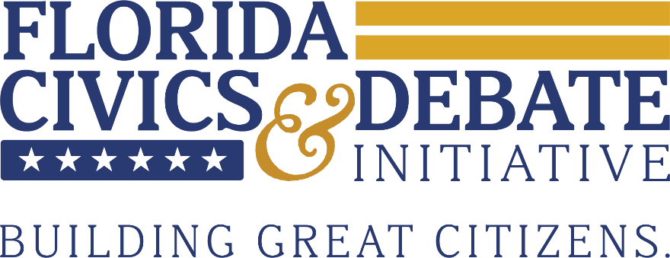
Florida Civics & Debate Initiative State Championship
Semifinals Legislation
Students shall assume the role of US Congress for the semifinal round of the State Championship.
Table of Contents
101. A Bill to Authorize the Use of Force Against Iran
102. A Bill to Increase Budget Accountability in the Department of Education
103. A Bill to Regulate the Sand Wars
101. A Bill to Authorize the Use of Force Against Iran
BE IT ENACTED BY THE CONGRESS HERE ASSEMBLED THAT:
Section 1. The President is authorized to use all necessary and appropriate force, proportional to the threat posed while minimizing civilian casualties, against the Islamic Republic of Iran, including its armed forces, affiliated militias and any state-sponsored proxy forces, under the following circumstances:
- If Iran commits or materially supports an armed attack against the US, its territories, citizens, military or allies;
- If credible and verifiable intelligence demonstrates that Iran or Iranian-sponsored forces pose an imminent threat of armed attack against the US, its military or allies;
- If military action is determined to be necessary to prevent Iran from developing, acquiring, weaponizing or deploying nuclear weapons capabilities, including actions targeting nuclear enrichment facilities, weapons development sites, missile systems or related military infrastructure.
Section 2. Imminent threat is defined as a clear and present danger, supported by credible intelligence, indicating that an armed attack is forthcoming. Necessary and appropriate force includes the use of US Armed Forces, cyber operations, intelligence operations and other military actions required to neutralize the threat. Nuclear weapons capabilities are defined as facilities, materials, technologies or activities directly related to the enrichment of uranium, development of nuclear weapons or delivery systems intended for nuclear weapons.
Section 3. The Department of War shall oversee military operations conducted pursuant to this authorization.
- The President shall submit a report to Congress within 48 hours of exercising this authority detailing objectives, scope of operations, estimated costs, risks and justification.
- Continued use of force under this authorization shall require updated reporting to Congress every 30 days.
SECTION 4. This legislation will take effect immediately upon passage.
SECTION 5. All laws in conflict with this legislation are hereby declared null and void.
Introduced for Legislative Debate by FCDI Staff.

102. A Bill to Increase Budget Accountability in the Department of Education

BE IT ENACTED BY THE CONGRESS HERE ASSEMBLED THAT:
Section 1. The following reforms shall be made to the federal Department of Education:
- Annual appropriations for the Department of Education shall not be reduced by more than 12 percent compared to the prior fiscal year.
- Federal funding for Diversity, Equity and Inclusion (DEI) programs within the Department of Education shall be limited to no more than 20 million dollars annually.
- Private universities with endowments exceeding 5 billion dollars shall be ineligible to receive federal funds from the Department of Education.
Section 2. Endowments are defined as the total value of all financial assets held by a university, including donations, investment portfolios and other assets or funds. DEI programs are defined as initiatives, offices or programs that prioritize diversity, equity or inclusion factors, including race, ethnicity, gender, socioeconomic background or other characteristics in addition to, or instead of, traditional academic or performance-based merit.
Section 3. The Office of Management and Budget, in conjunction with the Department of Education, are responsible for implementing this legislation.
- The Department of Education shall submit an annual report to Congress detailing the activities, objectives and costs relating to DEI programs.
SECTION 4. This legislation will take effect FY 2027.
SECTION 5. All laws in conflict with this legislation are hereby declared null and void.
Introduced for Legislative Debate by FCDI Staff.
103. A Bill to Regulate the Sand War
BE IT ENACTED BY THE CONGRESS HERE ASSEMBLED THAT:
Section 1. The following regulations shall be put in place to regulate the extraction of sand for the production of cement products:
- No person, company or government entity shall extract sand for cement production in amounts exceeding the following annual limits per ecosystem area: 500,000 tons from seafloor areas, 200,000 tons from coastlines or dunes and 200,000 tons from inland rivers, lakes or other sensitive ecosystems, unless otherwise authorized by the EPA.
- Extraction shall not occur within 1,000 meters of protected ecosystem areas, including designated wetlands, coral reefs and critical wildlife habitats.
- 20 billion dollars shall fund research and development into alternative cement technologies, including geopolymer concrete, recycled aggregates, manufactured sand and other sand alternatives.
- All entities conducting extraction projects must submit a comprehensive environmental impact assessment to the EPA prior to extraction and report the volume, source and purpose of the sand to be removed.
Section 2. Alternative cement technologies are defined as methods or materials that reduce reliance on natural sand and traditional Portland cement, including but not limited to geopolymer concrete, recycled aggregate concrete, manufactured sand (M-sand) and high-volume supplementary cement materials. Environmental impact assessment is defined as a detailed report projecting the potential environmental effects of sand extraction, including impacts on ecosystems, water quality, wildlife, long term sustainability and local communities.
Section 3. The Environmental Protection Agency, in coordination with the Department of the Interior, shall oversee the implementation of this legislation.
- Entities that do not follow extraction restrictions or reporting requirements may face penalties including fines, suspension of extraction permits or other penalties as deemed necessary.
SECTION 4. This legislation will take effect on FY 2028.
SECTION 5. All laws in conflict with this legislation are hereby declared null and void.
Introduced for Legislative Debate by FCDI Staff.

